Neural network model

# Define the neural network structure

## 2-layer neural network

In 2-layer neural network, we usually use Linear->sigmoid->output pattern to construct our model. Linear activation function is relu, while nonlinear activation function is sigmoid.

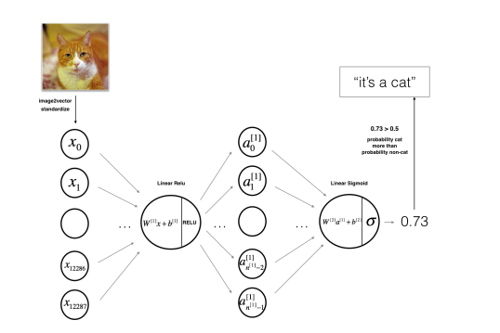

## L-layer neural network

In L-layer neural network, we use [LINEAR -> RELU] **×** (L-1) -> LINEAR -> SIGMOID (whole model).

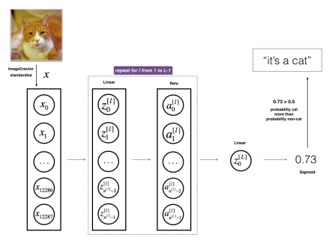

# Initialize parameters

## 2-layer parameters

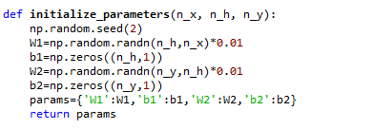

## L-layer parameters

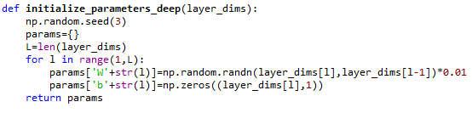

# Forward propagation

## Activation forward

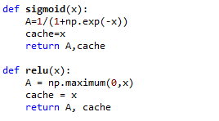

## 2-layer forward propagation

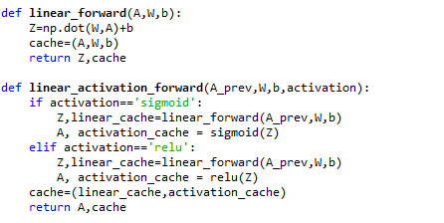

## L-layer forward propagation

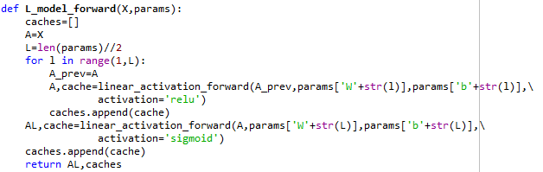

# Cost function

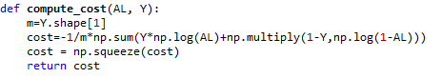

# Backward propagation

## Activation backward

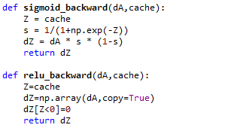

## 2-layer backward propagation

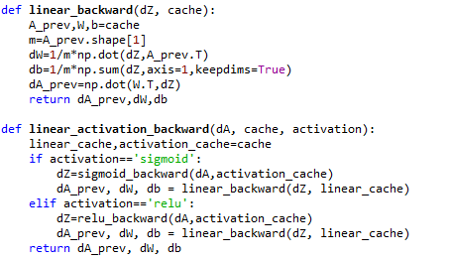

## L-layer backward propagation

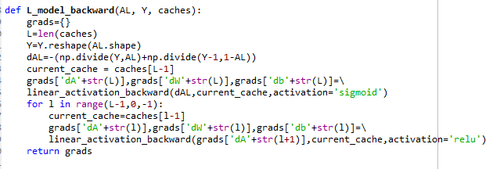

# Update parameters

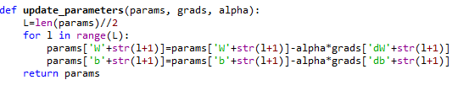

# Application

Build a neural network to distinguish cat images from non-cat images. We use 2-layer neural network and L-layer neural network, and the compare performance of two models and try out different L.

## General methodology

As usual we build a deep neural network model, we can use following method:

1. Initialize parameters
2. Loop for iteration
   1. Forward propagation
   2. Cost function
   3. Backward propagation
   4. Update parameters, using parameters and gradient from backward propagation
3. Use training parameters to predict results.

## 2-layer model

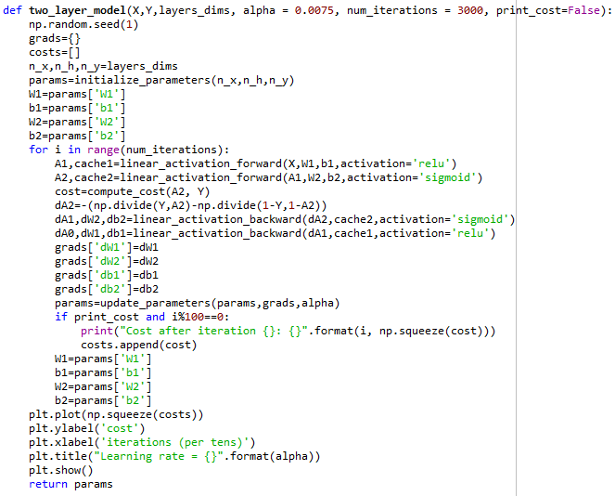

## L-layer model

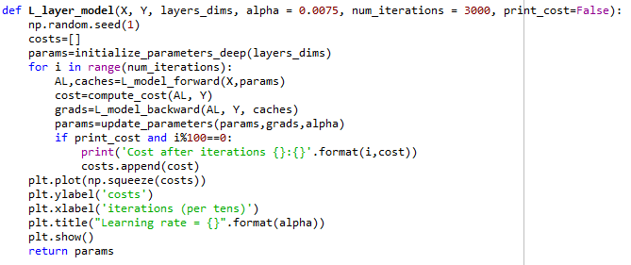

# Result analysis

## 2-layer model

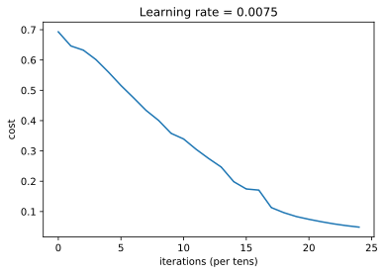

## L-layer model

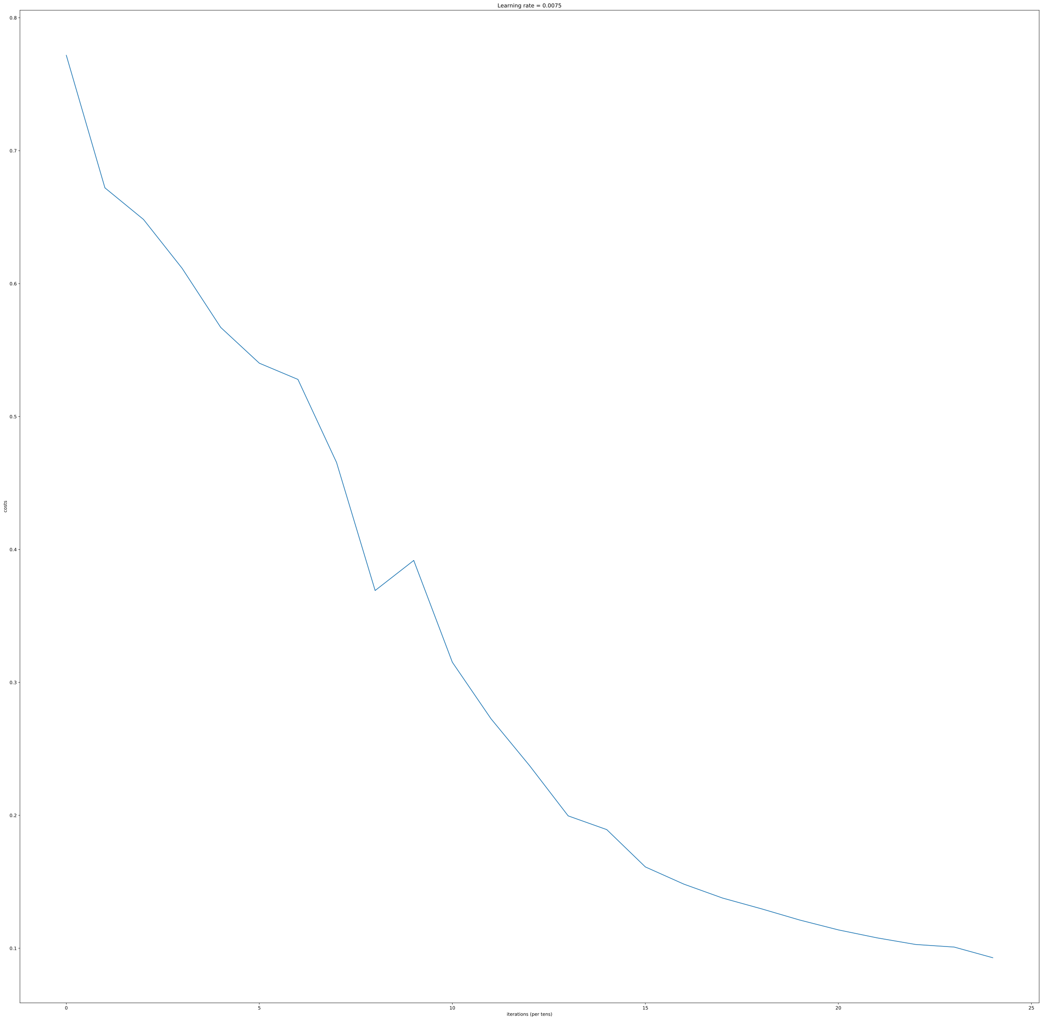

## Result and Analysis

|  |  |  |
| --- | --- | --- |
| methods | Train accuracy | Test accuracy |
| Logistic | 0.995 | 0.68 |
| 2-layer neural network | 0.9999999999999998 | 0.72 |
| L-layer neural network | 0.9856459330143539 | 0.80 |

In 2-layer model, running model on few iteration gives a better accuracy on the test set, and it seems that 2-layer neural network has better performance than logistic classification. L-layer neural network has even better performance than 2-layer neural network. Hidden layer sometimes do a good benefit for neural network.

Then we find that a few type of images the model tends to do poorly on include: positions, colors, and appears, brightness, which the features do not show in training data.